Acousto-optic modulator (AOM) used in the monitor is sketched in Figure 1. These devices are called Holochips which have some adjustments compared to the old-style AOMs. In these Holochips we are using grating input couplers to couple light into the waveguide. This brings down the price of an AOM to a couple dollars compared to the traditional spatial light modulators which costed around $500 since a prism must be used to couple light into the waveguide. As seen in Figure 1, TE light hits the grating and couples into the waveguide through the grating input couplers, then it interacts with the surface acoustic waves (SAWs) created by interdigital transducers (IDTs). This results in a change in the momentum of the light, therefore the propagation direction of light changes and the polarization of light switches to TM. As a result the light will not be waveguiding anymore and it leaks out of the waveguide, this is why these devices are called leaky-wave modulators.

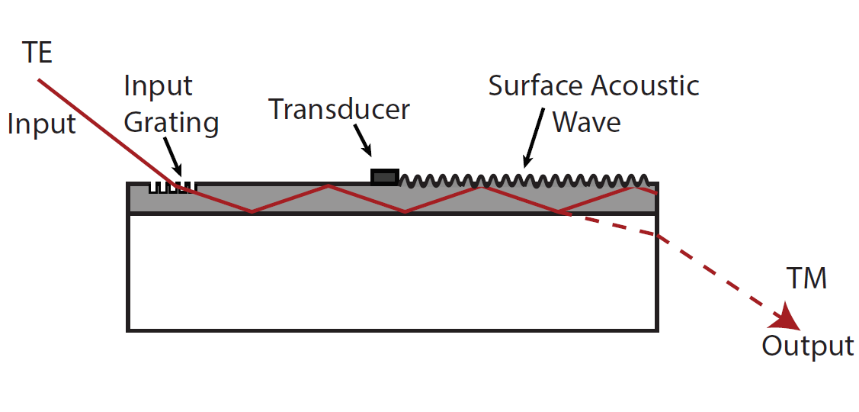
Figure 1: TE light enters the waveguide as a high-order guided mode, then, interacts anisotropically with the surface acoustic wave. The result of this interaction is that a portion of the guided light is polarization rotated and therefore no longer guided. The light then exits the waveguide as TM-polarized leaky-mode light.

Figure 2 shows the complete configuration of a final fabricated holochip inside a cartridge. The cartridge contains a LASER and the holochip. The holochip first needs to be aligned so the laser is hitting the grating input coupler and then couples into the right mode at the right angle. For this specific device, the angle is about 40º. Then, an RF voltage of 350-450 MHz bandwidth is applied to the IDTs. Once an efficient, wide-band deflected beam is observed, we start gluing down the holochip and the lens in place so they don’t move.
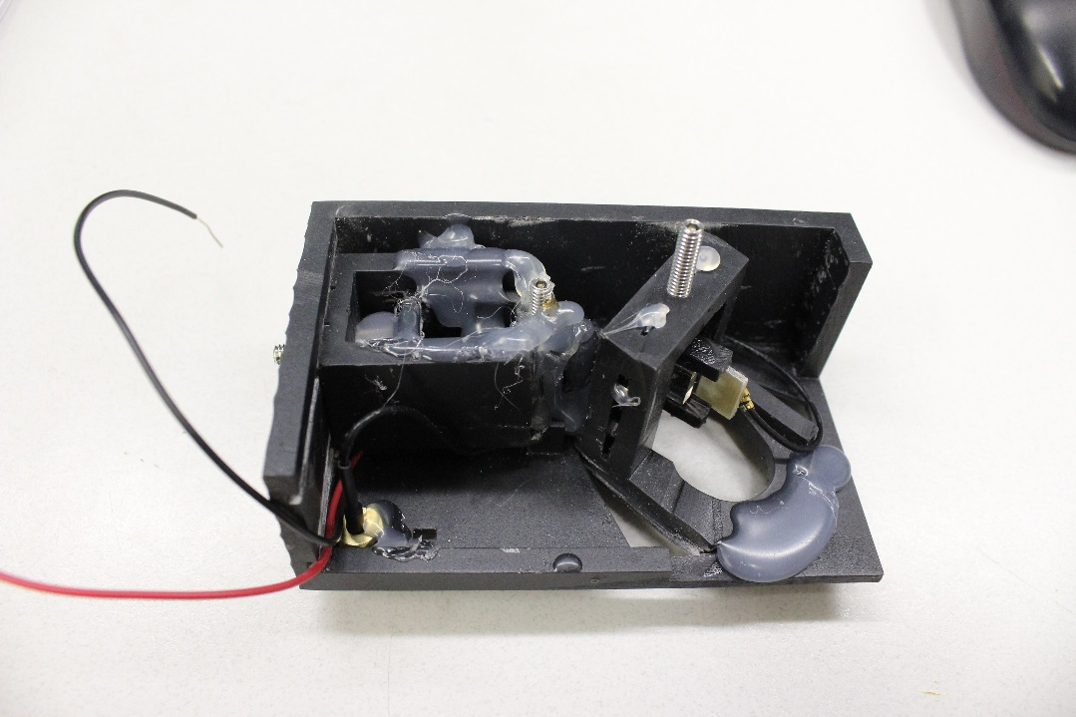
Figure 2: A complete Holochip inside a cartridge glued down in place, ready to be used in a near eye display.

