Optimized guided to leaky mode device for GPU controlled frequency division of color
S. McLaughlin,¹ C. Leach,¹ A. Henrie,¹ and D. E. Smalley^{3,*}
¹Electrical and Computer Engineering Department, Brigham Young University, 459 Clyde Building, Provo, UT 84602, United States of America
*Corresponding author: smalley@byu.edu
Received Month X, XXXX; revised Month X, XXXX; accepted Month X, XXXX; posted Month X, XXXX (Doc. ID XXXXX); published Month X, XXXX
We present fabrication parameters for an annealed proton exchanged lithium niobate guided wave modulator, which has been optimized for frequency division color multiplexing. We achieve a design that reduces the necessary drive bandwidth by more than half to match the 200MHz bandwidth of commodity GPU outputs. By matching the device bandwidth to that of the GPU outputs, we have made possible highly parallel and scalable color waveguide displays.
a
OCIS codes: (090.2870) Holographic display; (130.3120) Integrated optics devices; (130.3730) Lithium niobate; (130.7408) Wavelength filtering devices..
http://dx.doi/org/10.1364/AO.99.099999

1. Introduction

Modern displays achieve color operation by multiplexing color in time, using a filter wheel, or in space, by having dedicated red, green and blue pixels. Recently, it has been shown that this can be accomplished for waveguide displays by multiplexing in frequency [1] . This is particularly convenient for waveguide displays as every waveguide channel can be continuously illuminated with multiple, superimposed colors, greatly simplifying the design of large, integrated displays that would otherwise require complex light delivery systems[2].
Frequency multiplexing of color is also of particular interest to holographic displays, because bandwidth is of critical importance in these systems. Holographic video displays typically require many orders of magnitude more information than traditional displays. However, this information could be delivered in parallel with a number of low bandwidth signals rather than with one very large bandwidth signal [3]. One of the best ways of providing this information in parallel, is with banks of commodity GPUs, which are relatively inexpensive and capable of computing holographic information on the fly [4]. These GPUs have a 200MHz output bandwidth for each channel of output. We seek to create waveguide devices that can have their output color and output angle fully controlled with an up converted signal bandwidth of 200MHz. In this way, we can create displays of arbitrary size by adding GPU and waveguide channels in parallel [5]. For context, eighteen such channels would create a standard resolution holographic display the size of a postcard and a five hundred channel display would have a diagonal of a meter or more.
This paper provides the first design methodology for frequency division of color in leaky mode waveguide displays.

2. Background

Frequency division multiplexing of color has been accomplished with guided to leaky mode transitions in annealed proton-exchanged lithium niobate waveguides. A proton exchanged waveguide on an x-cut lithium niobate wafer will support a number of guided modes, TE_{N}, and a few leaky modes, TM_{N_ Leaky}. For waveguides deep enough to support red, green and blue modes there are many possible TE_{N}- TM_{N_ Leaky} transitions. You can greatly modify the function of the frequency division in a waveguide device by carefully choosing which transitions will be used for the modulation of each color.

3. Design and Fabrication

A. Design Principles
We seek to create a device that can modulate red, green and blue light all within a 200MHz band. We would also like to have each band of color operation be as wide as possible so as to waste as little of this 200MHz bandwidth as possible. To achieve this goal, the following design principles must be kept in mind: 1) the deeper the waveguide, the narrower the bandwidth of the guided to leaky mode transition, 2) for proton exchanged waveguides, the transitions from higher order modes are more efficient [6], 3) short anneal times create guided wave modes closer together toward higher effective indices, and longer anneal times create modes that are closer at lower effective indices.
B. Fabrication
We begin by first proton exchanging x-cut (y-propagating) lithium niobate for as little as possible so that we have a waveguide at the minimum possible depth and maintain the widest possible bandwidth for color transitions. At very small depths, we will get guided to leaky mode transitions for blue only. Then as the waveguide depth increases, we will see transitions in green, and finally, red. We stop at the depth that allows one guided to leaky mode transition in red. The creation of the waveguide includes an anneal step that we want to be relatively long so that the resulting guided modes will be bunched closer together at low effective index which corresponds to higher order guided modes which we prefer for their more efficient transitions.
In practice, we proton exchange the sample in a melt of pure benzoic acid at 238 ‘C for 10 minutes. Afterward, the sample is annealed at 375 ‘C for 45 minutes in a muffle furnace. At the end of the anneal period, the sample is left in the oven with the door open, where it continues to anneal the as it cooled for several hours. The resulting waveguide has two modes with effective indices of 2.2275 and 2.2077 for 633nm light as measured in a Metricon prism coupler.
In order to reproduce the results in this work, it is necessary to create a waveguide with guided modes that have effective indices as close as possible to those shown above. These parameters will change as a strong function of melt age, volume, and temperature as well as exchange time.
Red has two guided modes which we will call TE₀ and TE₁ with the fundamental mode, TE₀, being the guided mode with the higher effective index. Green has three guided modes, TE₀, TE₁ and TE₂ and blue has four guided modes, TE₀, TE₁, TE₂ and TE₃. Each color also has at least one leaky mode (the fundamental) which we will call TM_{0_Leaky}.
.
C. Choosing Guided to Leaky Mode Transitions

Figure 1 shows the frequency response and corresponding angular output of light out coupled from guided to leaky mode transitions for a device fabricated as described above. The first row shows transitions from the highest order guided mode to the fundamental leaky mode: TE₁-TM_{0_Leaky} for red, TE₂-TM_{0_Leaky} for green and TE₃-TM_{0_Leaky} for blue. The second row shows the response for transitions from the second highest order guided mode to the fundamental leaky mode: TE₁-TM_{0_Leaky} for green and TE₂-TM_{0_Leaky} for blue with no transition for red. The third row shows the response for the transition from the third highest order guided mode to the fundamental leaky mode: TE₁-TM_{0_Leaky} for blue with no transitions for red or green. Notice that there is only one guided to fundamental leaky mode transition for red—this was by design, since we halted the deepening of the waveguide when this transition was to appear. Green light has two possible transitions and blue has three available transitions.
Initially, it would be natural to choose the transitions shown in the first row of Figure 1. (This response is isolated and shown in Figure 2.) The frequencies controlling red, green and blue are well separated and the output light has very good overlap in output angle. Both of these attributes are desirable. Unfortunately, it would be necessary to have a drive signal that spans a bandwidth greater than 400MHz to control these transitions.

To achieve our goal of a drive bandwidth of 200MHz, red, green and blue transitions must be closer together in frequency space. This can be achieved if we choose the highest mode transition for red, the second highest mode transition for green and the third highest mode transition for blue. That is TE₁-TM_{0_Leaky} for red, green and blue producing the response shown in Figure 3.
By choosing the first transition for red, the second for green and the third for blue we reduce the required bandwidth by half to approximately 200MHz. 200Mhz is precisely the amount of bandwidth currently available from commodity GPUs. Furthermore, the individual color passbands show good separation in frequency and minimal wasted bandwidth. There is still good angular overlap in the output angle of each color, but not as good as the overlap shown in Figure 2. However, this overlap can be further improved, even doubled, by using a prism at the output or by polishing the output face of the device at an angle.

Conclusion

We have fabricated a guided to leaky mode modulator which has been optimized for frequency division color operation with a 200MHz bandwidth of operation. By matching the bandwidth of the device to commodity GPU outputs we enable the straightforward creation of parsimonious and highly parallel color waveguide displays.
The authors gratefully acknowledge Dr. Stephen Schultz for use of key pieces of laboratory equipment and for fruitful discussion. This research was supported by the Air Force Research Laboratory contract FA8650-14-C-6571
References
1. Smalley, D.E., et al., Anisotropic leaky-mode modulator for holographic video displays. Nature, 2013. 498(7454): p. 313-317.
2. Smalley, D.E., V.M. Bove Jr, and Q.Y.J. Smithwick, Anisotropic Leaky-Mode Modulator for Holographic Video Displays. 2014, MIT. Patent Number US20140300694 A1
3. St-Hilaire, P., Scalable optical architecture for electronic holography. Optical Engineering, 1995. 34(10): p. 2900-2911.
4. Smithwick, Q.Y., et al. Real-time shader rendering of holographic stereograms. in SPIE OPTO: Integrated Optoelectronic Devices. 2009. International Society for Optics and Photonics.
5. Smalley, D., et al. Holovideo for everyone: a low-cost holovideo monitor. in Journal of Physics: Conference Series.
6. Rust, U. and E. Strake. Acoustooptical Coupling of Guided to Substrate Modes in Planar Proton-Exchanged LiNbO3-Waveguides. in Integrated Photonics Research.

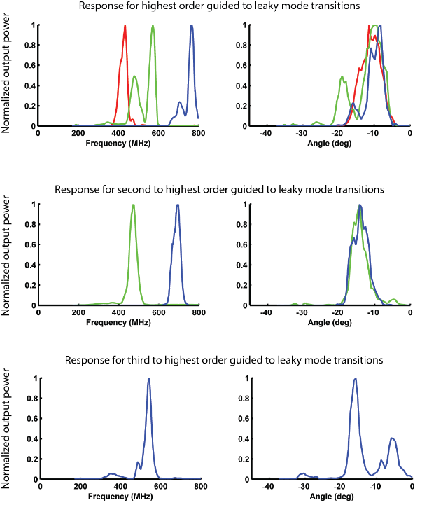
Fig. 1. The graphs above show frequency response and angular response for guided to leaky mode transitions in our optimized waveguide device. The first column shows RF frequencies which result in guided to leaky mode conversion. When light is converted, it exits the output face of the device at an angle which varies as a function of the input RF frequency. The second column gives the range of output angles scanned by the exiting light. The first row gives the response for transitions from the highest order guided modes and the fundamental leaky mode. The second and third columns give the response of transitions from the second highest guided modes and third highest respectively.

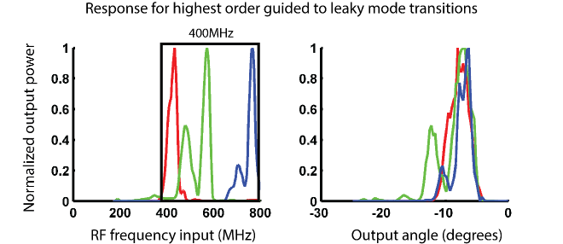
Fig. 2 These graphs show the frequency and angular response for transitions from the highest guided modes to the fundamental leaky mode. The required drive bandwidth is 400MHz.

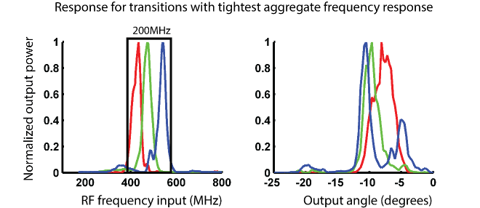
Fig. 3. These graphs show the frequency and angular response for transitions from the highest guided mode for red, the second highest guided mode for green and the third highest guided mode for blue to the fundamental leaky mode. The required drive bandwidth has been reduced to 200MHz.

