RF Board Chain Testing

Hardware
- Plug the DVI cable into the DVI breakout board
- Put caps on the red and green lines (the two closest to the edge of the board)
- Plug power supply into Arduino
- Turn on power supply
- Plug ribbon cable into DVI breakout board
- Plug DVI cable into graphics card
On the Computer
- Start BYU HoloMonitor Sweeper Suite
  - SWEEP: AUTO
  - OUTPUT MODE: SEPARATE
  - RED ENABLE: off
  - Set all red settings to 0
  - GREEN ENABLE: off
  - Set all green settings to 0
  - BLUE ENABLE: on
  - BLUE MIN FREQ: 0
  - BLUE MAX FREQ: 200
  - BLUE AMP: 1
- Move the window displaying blue lines to the gigantic display on the left
- Press the ‘f’ key to make it full screen
- Set the SUITE RATE to slightly larger than 0
Oscilloscope
- Attach the output of the blue line to the oscilloscope
- Set the minimum frequency to 0 GHz
- Set the maximum frequency to 1 GHz
- Pressing MAX HOLD on the trace keeps the max values of the signal
- You should now have the unaltered blue signal on the scope
Hardware
- Attach the blue signal from the breakout board to the RF side of the mixer board
- Attach the output coming out of the top of the board to the oscilloscope
- Attach the other input to the board to the output of the signal generator
Signal Generator
- Set the frequency to 350 MHz
- Set the amplitude to 7.0dBm
- Only press the RF ON/OFF key when you are ready to use the signal (pressing the key toggles the output)
General and Results
When you are ready, turn on the signal from the signal generator. The output should display on the oscilloscope. Our results look like the following:
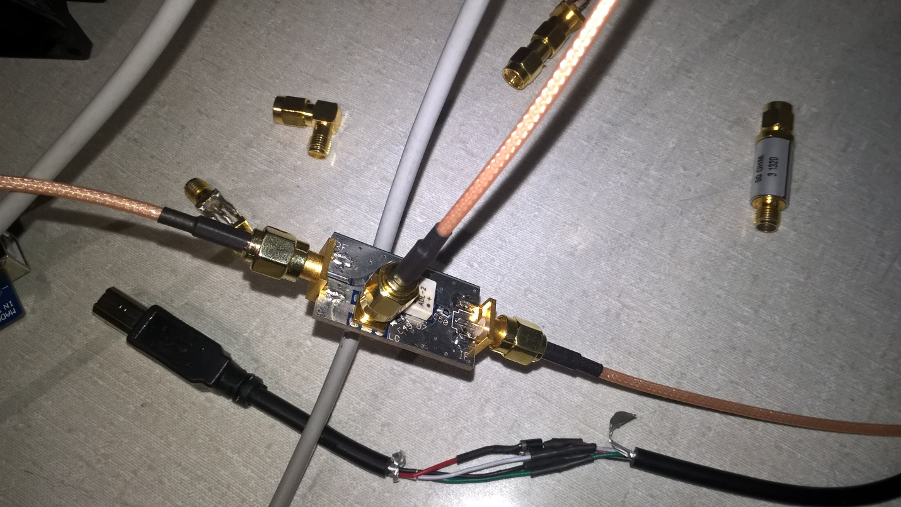
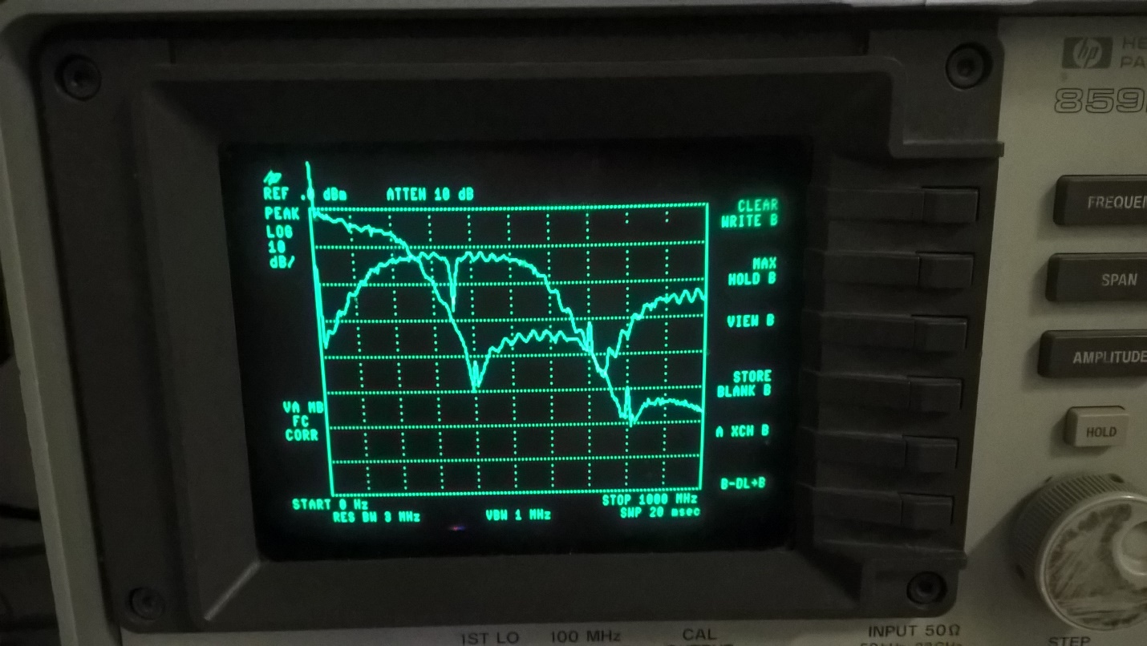
The signal that starts at 0 dB and comes down is the original blue signal. The other signal is the blue signal after going through the mixer.
Adding the Bandpass Filter
- Turn off the output from the signal generator
- Attach the bandpass filter to the output of the mixer board
- Attach the output of the filter to the oscilloscope
- Turn on the output from the signal generator
- Clear and capture the desired signals
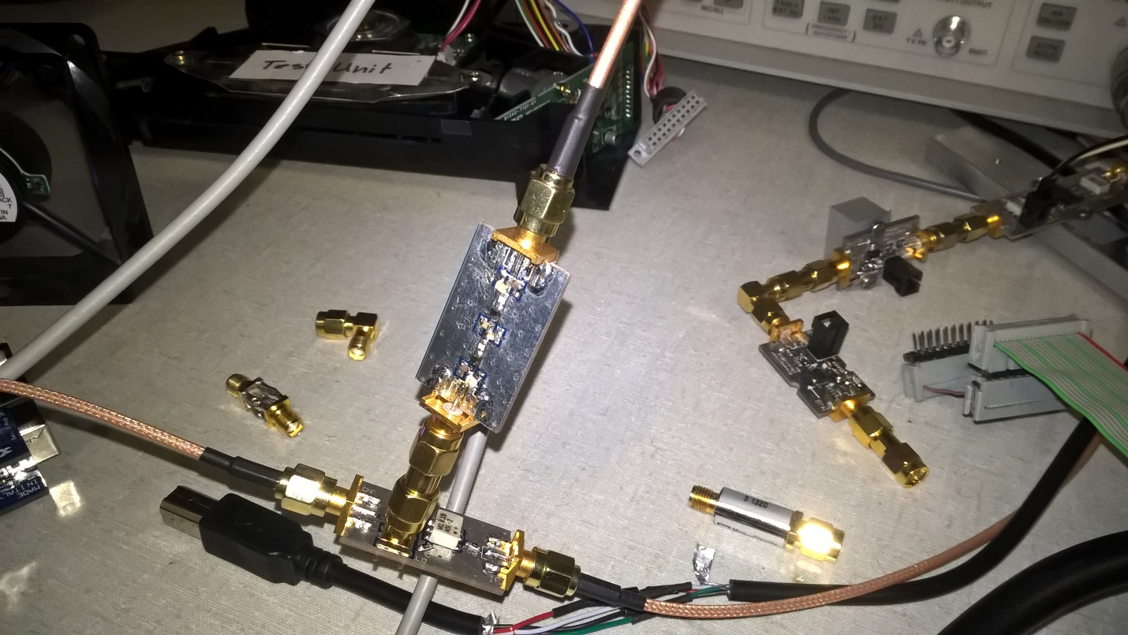
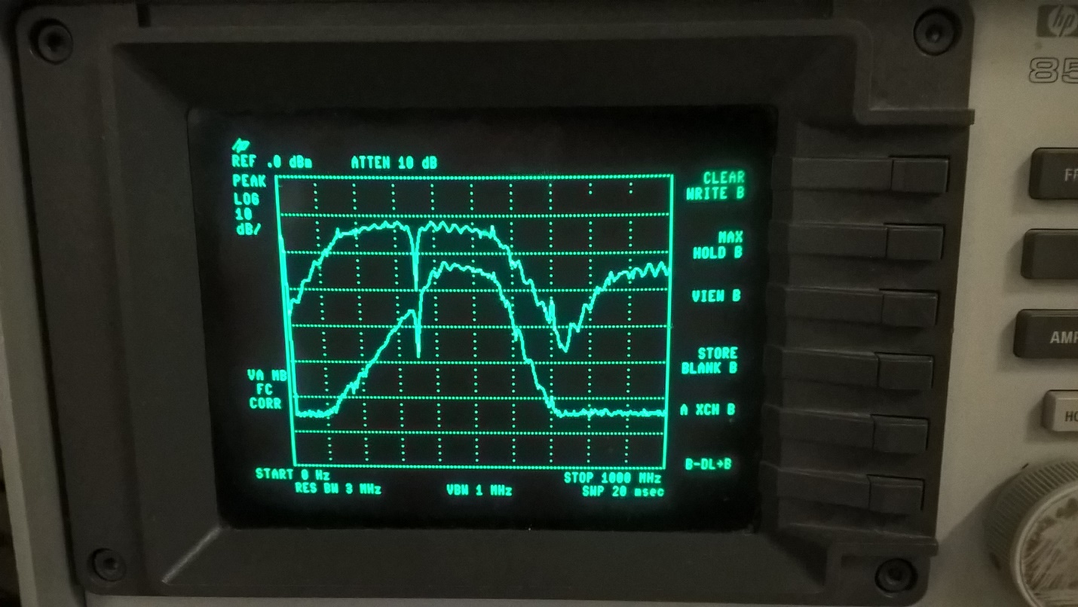
The top signal is the output after the mixer. The bottom signal is the output after the bandpass filter.

Adding the GVA-84 amplifier
- Turn off the output from the signal generator
- Attach the GVA-84 amplifier board to the output of the bandpass filter board
- Attach the output of the amplifier to the oscilloscope
- Attach the power supply to the power input and ground lines (it should be 5V and less than 160mA)
- Turn on the power supply
- Turn on the output from the signal generator
- Clear and capture the desired signals

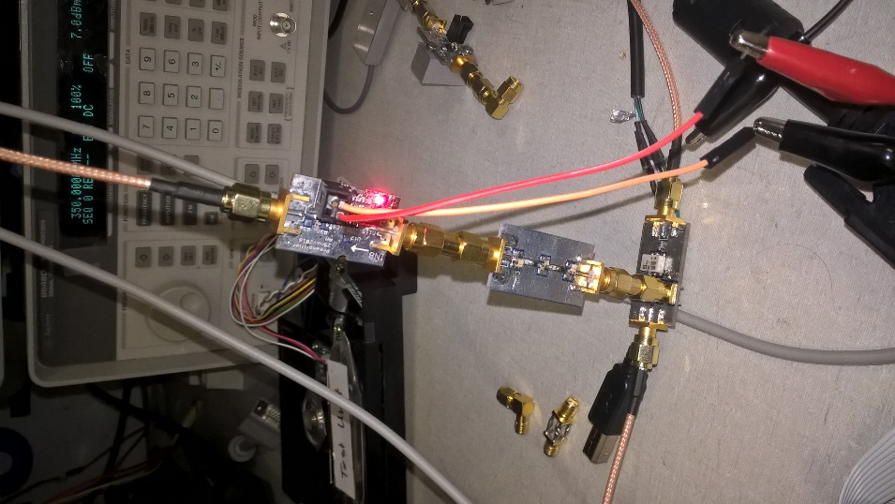
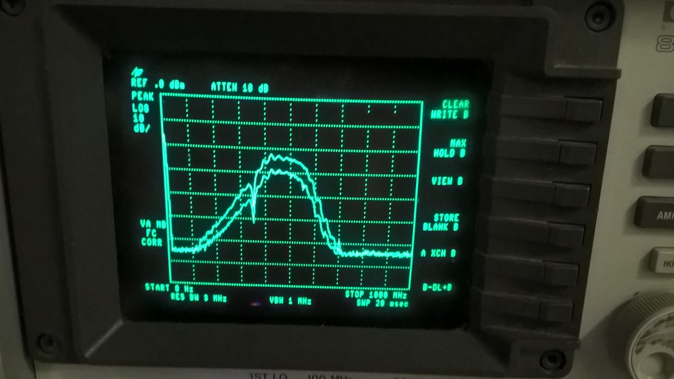
The top signal is the output of the filter. The bottom signal is the output of the GVA-84 amplifier after 30dB of attenuation.

Adding the PHA-101 amplifier
- Turn off the output from the signal generator
- Turn off the power supply to the GVA-84 amplifier
- Attach the PHA-101 amplifier board to the output of the GVA-84 amplifier board
- Attach the output of the amplifier to the oscilloscope
- Attach the power supply to the power input and ground lines (it should be 9V and less than 360mA)
- Turn on the power supplies for the amplifiers
- Turn on the output from the signal generator
- Clear and capture the desired signals
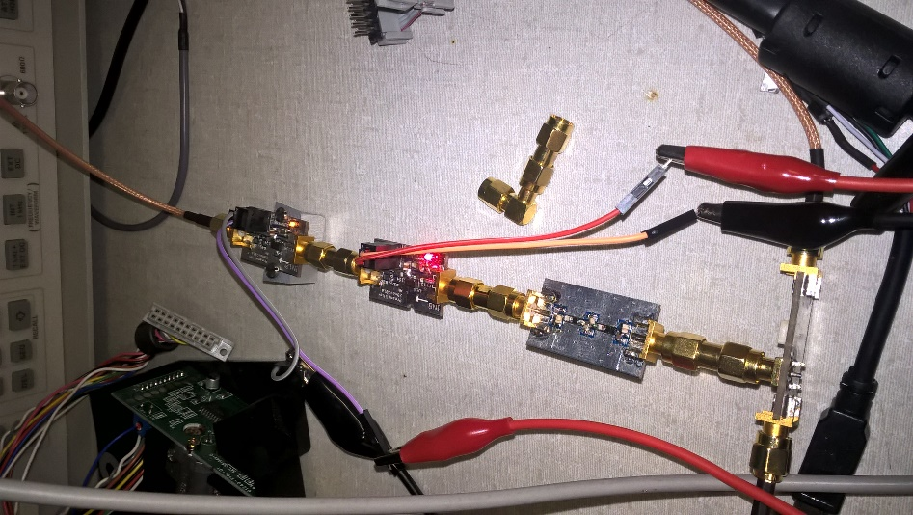
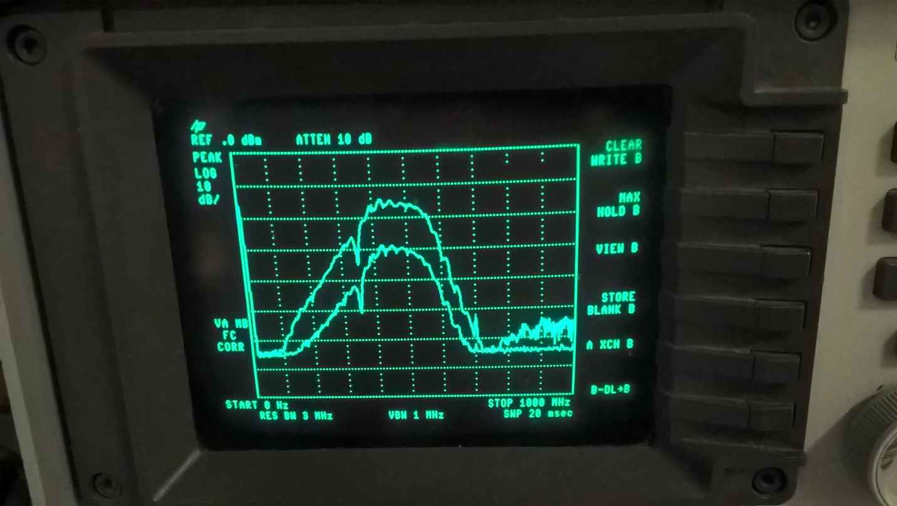
The bottom signal is the output of the GVA-84 amplifier. The top signal is the output of the PHA-101 amplifier.

Adding the HELA-10 amplifier
- Turn off the output from the signal generator
- Turn off the power supply to the amplifiers
- Attach the HELA-10 amplifier board to the output of the PHA-101 amplifier board
- Attach the output of the amplifier to the oscilloscope
- Attach the power supply to the power input and ground lines (it should be 12V and less than 525mA)
- Turn on the power supplies for the amplifiers
- Turn on the output from the signal generator
- Clear and capture the desired signals

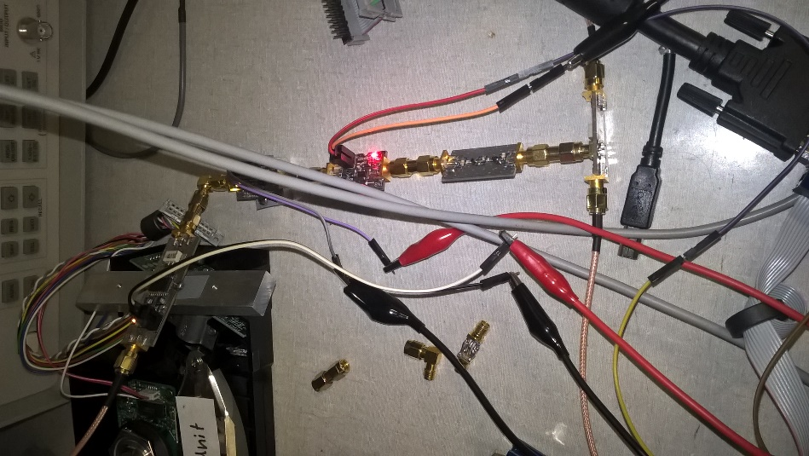
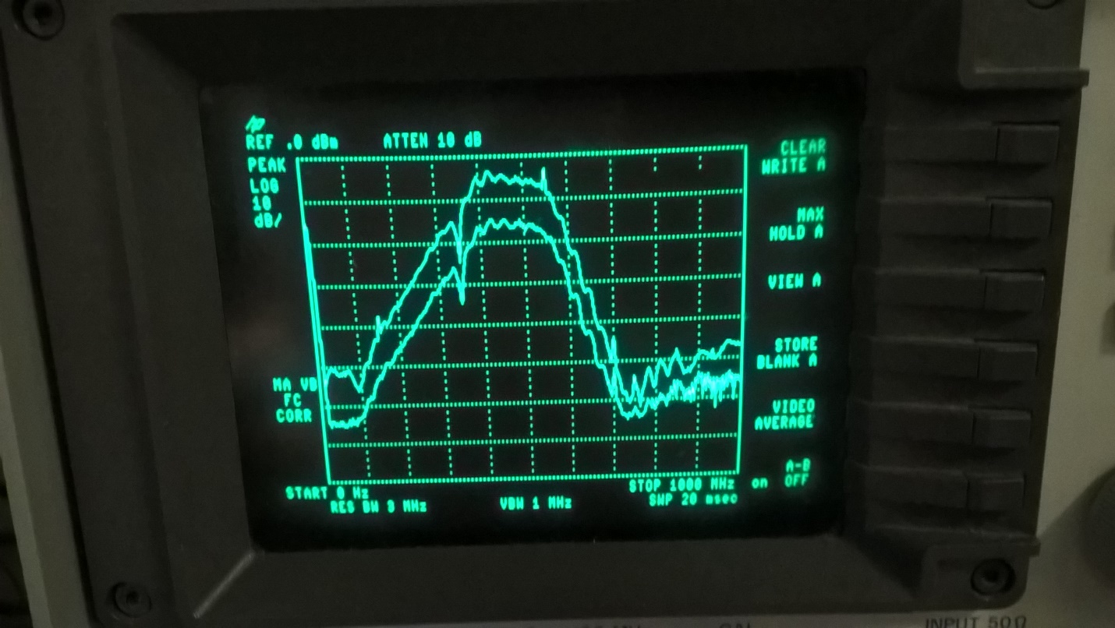
The bottom signal is the output of the PHA-101 amplifier. The top signal is the output of the HELA-10 amplifier.

